ICAD AWARD RECIPIENTS:
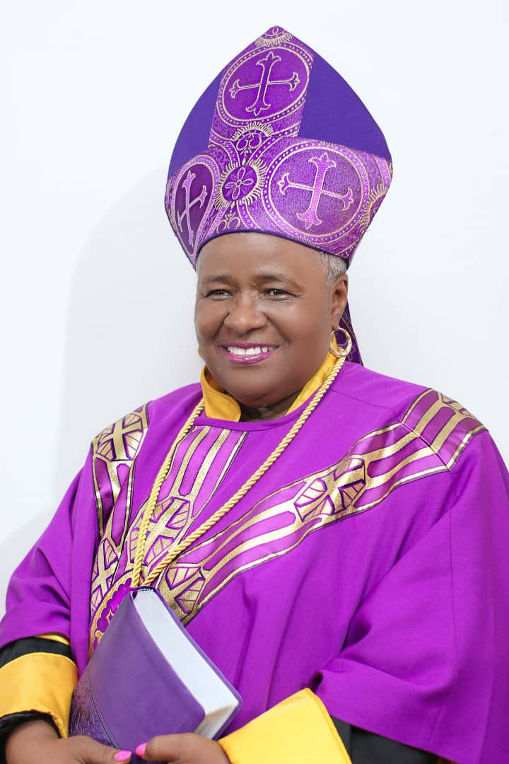
1. Arch Bishop Dr. Barbara Moore:
ICAD GLOBAL AMBASSADOR AWARD:
The ICAD GLOBAL AMBASSADOR AWARD recognizes individuals for their exceptional dedication to fostering global interfaith dialogue and cooperation. It celebrates efforts to transcend cultural and religious differences, promoting harmony and compassion worldwide. Recipients demonstrate unwavering commitment to peace, justice, and mutual respect, serving as inspirational figures in their community, country and beyond. This award honors those who tirelessly work to bridge divides and promote understanding, embodying universal values of love, empathy, and unity.

2. Arch Bishop Dr. William Wood:
ICAD LEADERSHIP EXCELLENCE AWARD:
The ICAD Leadership Excellence Award recognizes individuals who demonstrate exceptional leadership qualities, inspiring others through their vision, integrity, and ability to drive positive change. This prestigious accolade honors those who exhibit exemplary leadership skills, empowering teams to achieve extraordinary results while fostering a culture of collaboration and innovation.


3. Arch Bishop Dr. Mercy Wood:
ICAD COMMUNITY OUTREACH AWARD:
The ICAD Community Outreach Award recognizes individuals or groups for their outstanding efforts in engaging and uplifting their community through various initiatives. This accolade celebrates those who demonstrate exceptional commitment and innovation in addressing local needs and fostering positive change. Recipients of this award exemplify the spirit of service and make a tangible difference in enhancing the well-being and cohesion of their community.

4. PASTOR JENNIFER MOORE:
ICAD INNOVATIVE AWARD:
The ICAD Innovation Award recognizes groundbreaking advancements that push the boundaries of existing technology or methodology. It celebrates individuals or teams who have demonstrated exceptional creativity and ingenuity in solving complex problems. Recipients of this prestigious award inspire others with their inventive spirit and drive for progress.

5. Dr. Francis Mbroh
ICAD FINANCIAL & ECONOMIC INVESTMENT AWARD:
The ICAD Financial and Economic Investor Award recognizes individuals or entities who have demonstrated exceptional acumen and success in navigating the complexities of financial markets and investments. This prestigious award honors outstanding achievements in analyzing, strategizing, and executing lucrative financial decisions, contributing significantly to economic growth and prosperity.
Recipients of the ICAD Financial and Economic Investment Award exemplify a profound understanding of market dynamics, risk management, and innovative investment approaches, making notable contributions to shaping the landscape of global finance.


6. Apostle Bishop Dr. Jeff Crockett:
ICAD LEADERSHIP EXCELLENCE AWARD
The ICAD Leadership Excellence Award recognizes individuals who demonstrate exceptional leadership qualities, inspiring others through their vision, integrity, and ability to drive positive change. This prestigious accolade honors those who exhibit exemplary leadership skills, empowering teams to achieve extraordinary results while fostering a culture of collaboration and innovation.

ICA AWARD RECIPIENTS

1. Dr. Henry Binney:
ICA INNOVATIVE IN MINISTRY AWARD:
The ICA Innovative In Ministry Award recognizes religious leaders who pioneer creative approaches in their ministry, fostering engagement and relevance within their communities. It celebrates those who introduce fresh perspectives, utilize modern technology, and embrace progressive methodologies to address spiritual needs effectively. This accolade honors individuals who embody forward-thinking practices, inspiring others to adapt and evolve in their religious leadership roles.
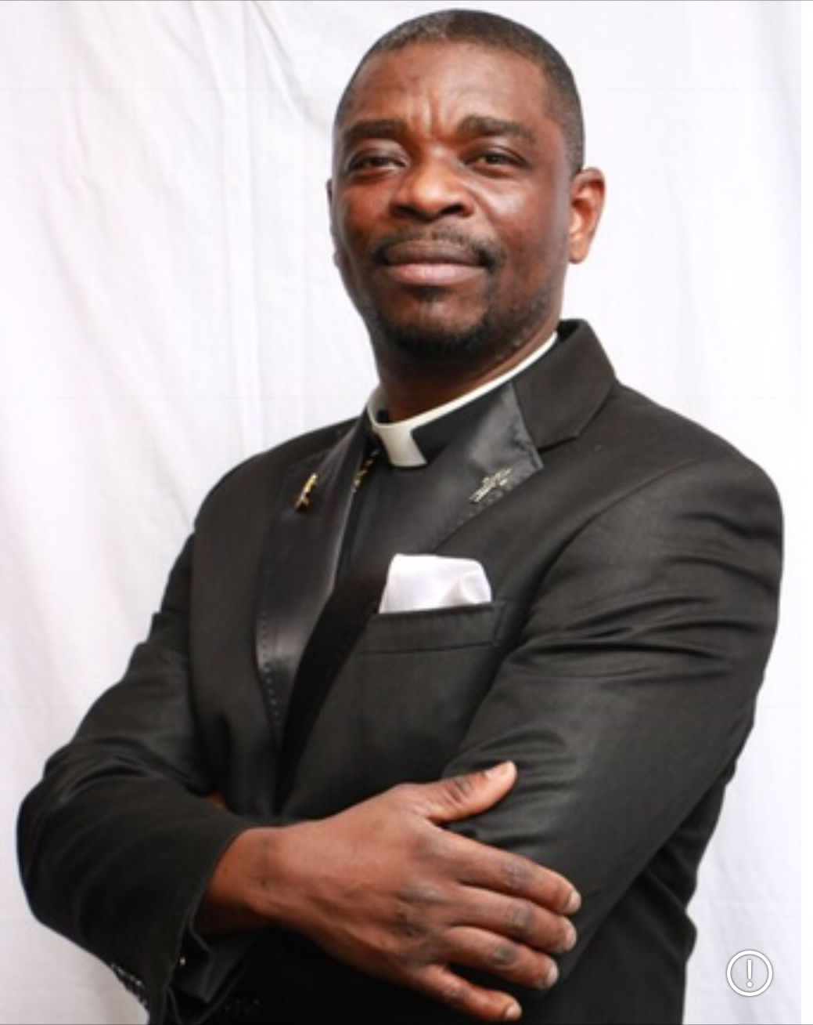
2. Bishop Stanley Osebre-Osei:
ICA GLOBAL AMBASSADOR AWARD:
The ICA GLOBAL AMBASSADOR AWARD recognizes individuals for their exceptional dedication to fostering global interfaith dialogue and cooperation. It celebrates efforts to transcend cultural and religious differences, promoting harmony and compassion worldwide. Recipients demonstrate unwavering commitment to peace, justice, and mutual respect, serving as inspirational figures in their community, country and beyond. This award honors those who tirelessly work to bridge divides and promote understanding, embodying universal values of love, empathy, and unity.8


3. Bishop Francis Sarpong:
ICA GLOBAL AMBASSADOR AWARD:
The ICA GLOBAL AMBASSADOR AWARD recognizes individuals for their exceptional dedication to fostering global interfaith dialogue and cooperation. It celebrates efforts to transcend cultural and religious differences, promoting harmony and compassion worldwide. Recipients demonstrate unwavering commitment to peace, justice, and mutual respect, serving as inspirational figures in their community, country and beyond. This award honors those who tirelessly work to bridge divides and promote understanding, embodying universal values of love, empathy, and unity.

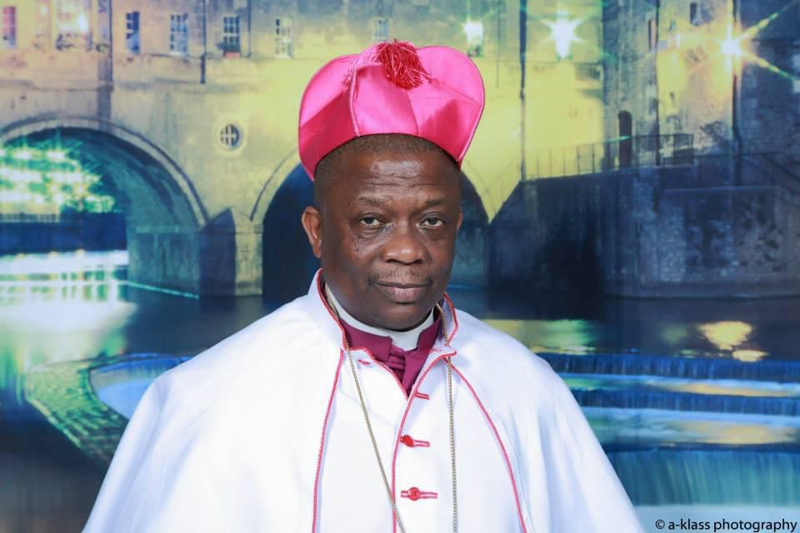
4. Arch Bishop Kwaku Frempong-Manso:
ICA GLOBAL AMBASSADOR AWARD:
The ICA GLOBAL AMBASSADOR AWARD recognizes individuals for their exceptional dedication to fostering global interfaith dialogue and cooperation. It celebrates efforts to transcend cultural and religious differences, promoting harmony and compassion worldwide. Recipients demonstrate unwavering commitment to peace, justice, and mutual respect, serving as inspirational figures in their community, country and beyond. This award honors those who tirelessly work to bridge divides and promote understanding, embodying universal values of love, empathy, and unity.


5. Rev. Melanie Hamilton:
ICA HUMANITARIAN EXCELLENCE AWARD:
The ICA Humanitarian Excellence Award recognizes individuals or organizations who have demonstrated outstanding dedication to alleviating human suffering and promoting humanitarian causes. Recipients are honored for their selfless actions, innovative approaches, and significant impact in improving the lives of those in need worldwide in providing essential social services, such as healthcare, education, food assistance, or shelter. This prestigious award celebrates exemplary compassion, courage, and commitment in the realm of humanitarian work.


6. Apostle Charles Nii Martey:
ICA EDUCATION & TRAINING EXCELLENCE AWARD:
The ICA Education & Training Excellence Award recognizes outstanding dedication and proficiency in educating and training individuals within religious studies. It honors those who demonstrate exceptional teaching skills, imparting knowledge with cultural sensitivity and theological depth. Recipients of this award inspire and empower their students, fostering a deep understanding and appreciation for religious principles and traditions.
Top of Form

ICA/ ICAD CONFERENCE 2024 (NETHERLANDS)


1. Mrs. Margit Appiah:
ICAD GLOBAL HUMANITARIAN EXCELLENCE AWARD:
The ICAD Humanitarian Excellence Award recognizes individuals or organizations who have demonstrated outstanding dedication to alleviating human suffering and promoting humanitarian causes. Recipients are honored for their selfless actions, innovative approaches, and significant impact in improving the lives of those in need worldwide in providing essential social services, such as healthcare, education, food assistance, or shelter. This prestigious award celebrates exemplary compassion, courage, and commitment in the realm of humanitarian work.


2. Bishop Joseph Appiah:
ICA GLOBAL AMBASSADOR AWARD:
The ICA GLOBAL AMBASSADOR AWARD recognizes individuals for their exceptional dedication to fostering global interfaith dialogue and cooperation. It celebrates efforts to transcend cultural and religious differences, promoting harmony and compassion worldwide. Recipients demonstrate unwavering commitment to peace, justice, and mutual respect, serving as inspirational figures in their community, country and beyond. This award honors those who tirelessly work to bridge divides and promote understanding, embodying universal values of love, empathy, and unity.


3. Dr. Sylvia Anie
ICAD Excellence Award in Public Health and Development Through Chemistry
This Award category recognizes individuals of their pioneering contributions to the intersection of chemistry, public health, and sustainable development. Their collaborative efforts have forged new paths in addressing global health challenges, leveraging the power of chemical research and innovation to advance public health initiatives worldwide.


4. Bishop Margaret Gono
ICA GLOBAL HUMANITARIAN EXCELLENCE AWARD:
The ICA Humanitarian Excellence Award recognizes individuals or organizations who have demonstrated outstanding dedication to alleviating human suffering and promoting humanitarian causes. Recipients are honored for their selfless actions, innovative approaches, and significant impact in improving the lives of those in need worldwide in providing essential social services, such as healthcare, education, food assistance, or shelter. This prestigious award celebrates exemplary compassion, courage, and commitment in the realm of humanitarian work.


5. Rev. Roger Amoah:
ICA LEADERSHIP EXCELLNCE AWARD
The ICA Leadership Excellence Award recognizes individuals who demonstrate exceptional leadership qualities, inspiring others through their vision, integrity, and ability to drive positive change. This prestigious accolade honors those who exhibit exemplary leadership skills, empowering teams to achieve extraordinary results while fostering a culture of collaboration and innovation.


6. Claudia George:
ICAD Visionary Artistry AWARD
The ICAD Visionary Artistry Award celebrates the imaginative prowess and innovative spirit of an artist whose creations transcend conventional boundaries, inspiring awe and wonder in their audience. This award honors the visionary artist or painter who fearlessly explores the realms of imagination, pushing the boundaries of artistic expression to new frontiers. Their works captivate the mind, provoke thought, and evoke emotions, inviting viewers to embark on a journey through the boundless landscapes of creativity. Through their visionary artistry, they challenge perceptions, ignite inspiration, and leave an indelible mark on the canvas of human consciousness. This award recognizes their exceptional talent, dedication, and relentless pursuit of artistic excellence, as they continue to shape the future of art with their visionary vision and unparalleled creativity.

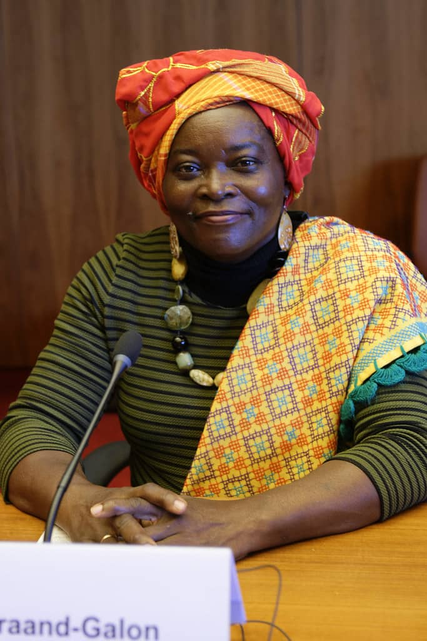
7. H.E. Fidelia Graand-Galon
Suriname Ambassador to Ghana

